**How Angular is boot strapped?**

Hierarchical component tree and at the top of the component tree is App Component.

CLI will create App Component for us. (component, css, style)

Boot strapping begins with Main.TS file and it is loaded by web pack, via the angular.Json file.

Then Main.Ts file loads the Apps module, and that makes aware of our app component

Then Index.html file is loaded in our browser it loads our app component. Which used the temple defined in the component.

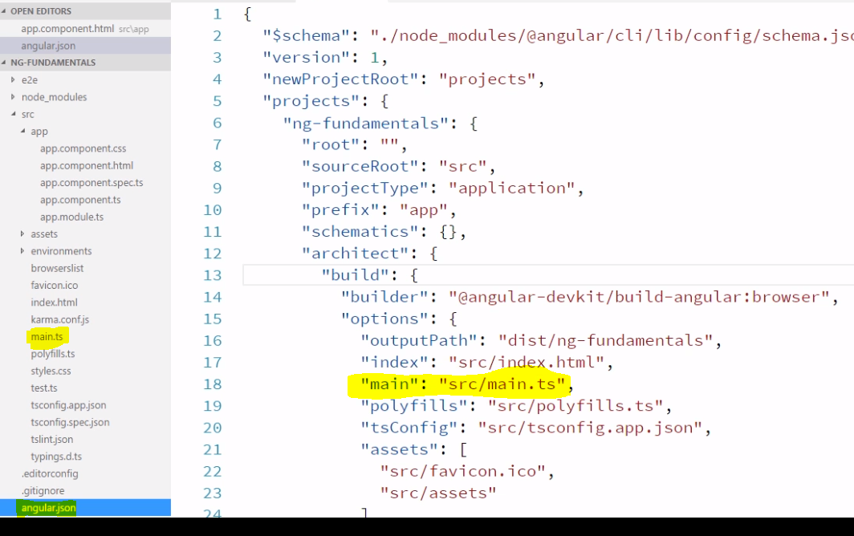

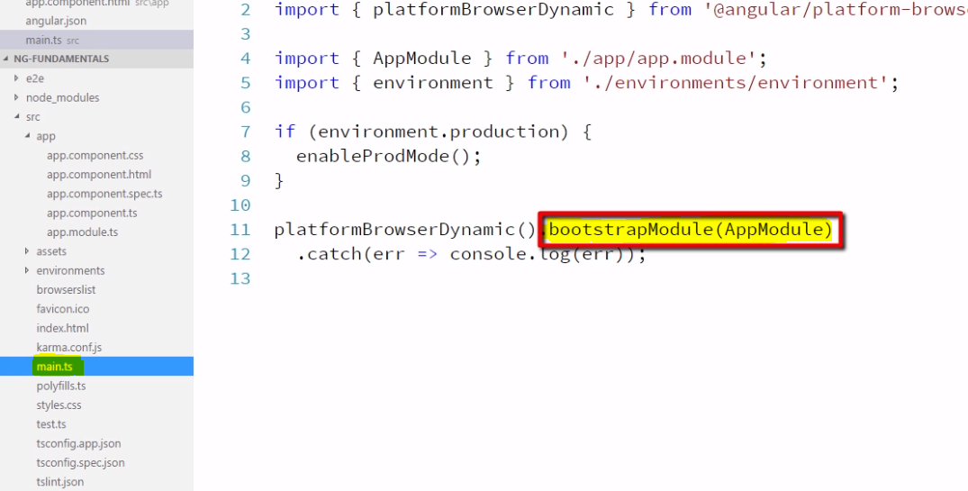

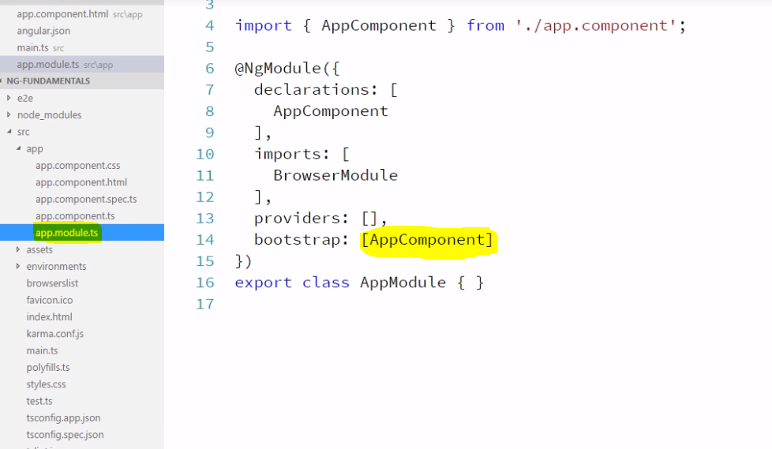

This is how angular knows how to load app component,

But how this is being displayed?

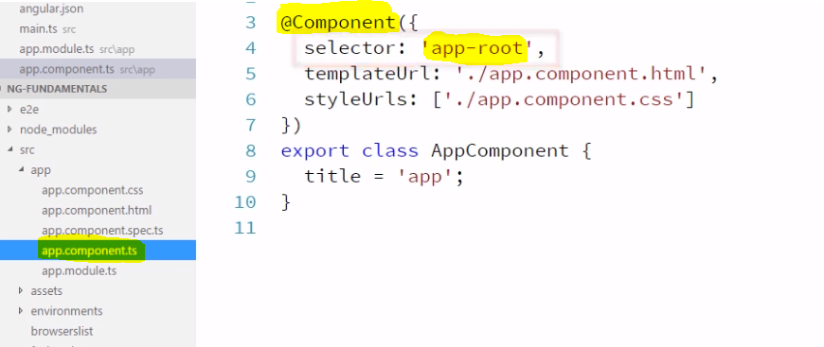

“app-root” Selector, this selector defines the html tag to use in order to display the component.

